**DIGITAL NURTURE 4.0 DEEP SKILLING JAVA FSE-WEEK1**

**NAME: SIVITHA GUNASEKARAN**

**SUPERSET ID: 6413354**

**WEEK 1: DESIGN PATTERNS AND PRINCIPLES**

**Exercise 8: Implementing the Strategy Pattern**

**Scenario:**

You are developing a payment system where different payment methods (e.g., Credit Card, PayPal) can be selected at runtime. Use the Strategy Pattern to achieve this.

**Steps:**

1. **Create a New Java Project:**
   * Create a new Java project named **StrategyPatternExample**.
2. **Define Strategy Interface:**
   * Create an interface PaymentStrategy with a method **pay()**.
3. **Implement Concrete Strategies:**
   * Create classes **CreditCardPayment**, **PayPalPayment** that implement **PaymentStrategy**.
4. **Implement Context Class:**
   * Create a class **PaymentContext** that holds a reference to **PaymentStrategy** and a method to execute the strategy.
5. **Test the Strategy Implementation:**
   * Create a test class to demonstrate selecting and using different payment strategies.

**CODE SAMPLES:**

**StrategyPatternExample.java**

interface PaymentStrategy {

void pay(double amount);

}

class CreditCardPayment implements PaymentStrategy {

public void pay(double amount) {

System.out.println("Paid ₹" + amount + " using Credit Card");

}

}

class PayPalPayment implements PaymentStrategy {

public void pay(double amount) {

System.out.println("Paid ₹" + amount + " using PayPal");

}

}

class PaymentContext {

private PaymentStrategy strategy;

public void setPaymentStrategy(PaymentStrategy strategy) {

this.strategy = strategy;

}

public void executePayment(double amount) {

strategy.pay(amount);

}

}

public class StrategyPatternExample {

public static void main(String[] args) {

PaymentContext context = new PaymentContext();

context.setPaymentStrategy(new CreditCardPayment());

context.executePayment(1200);

context.setPaymentStrategy(new PayPalPayment());

context.executePayment(750.5);

}

}

**MY SCREENSHOT PROOFS:**

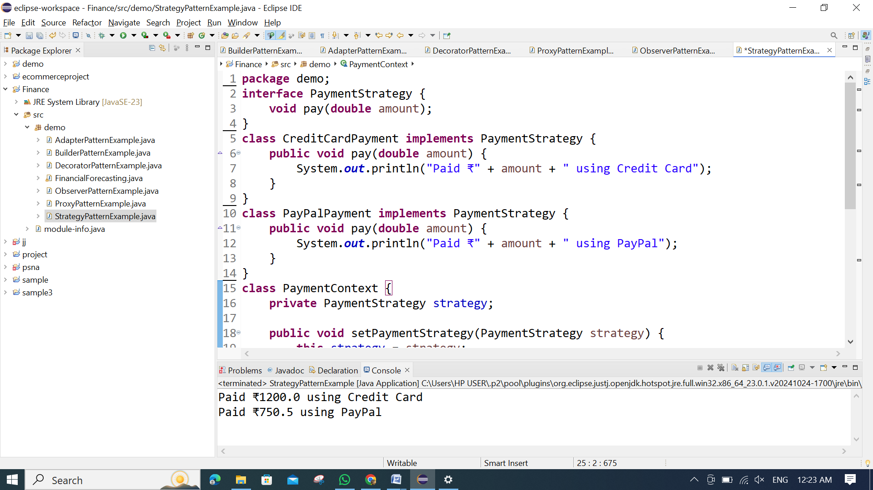

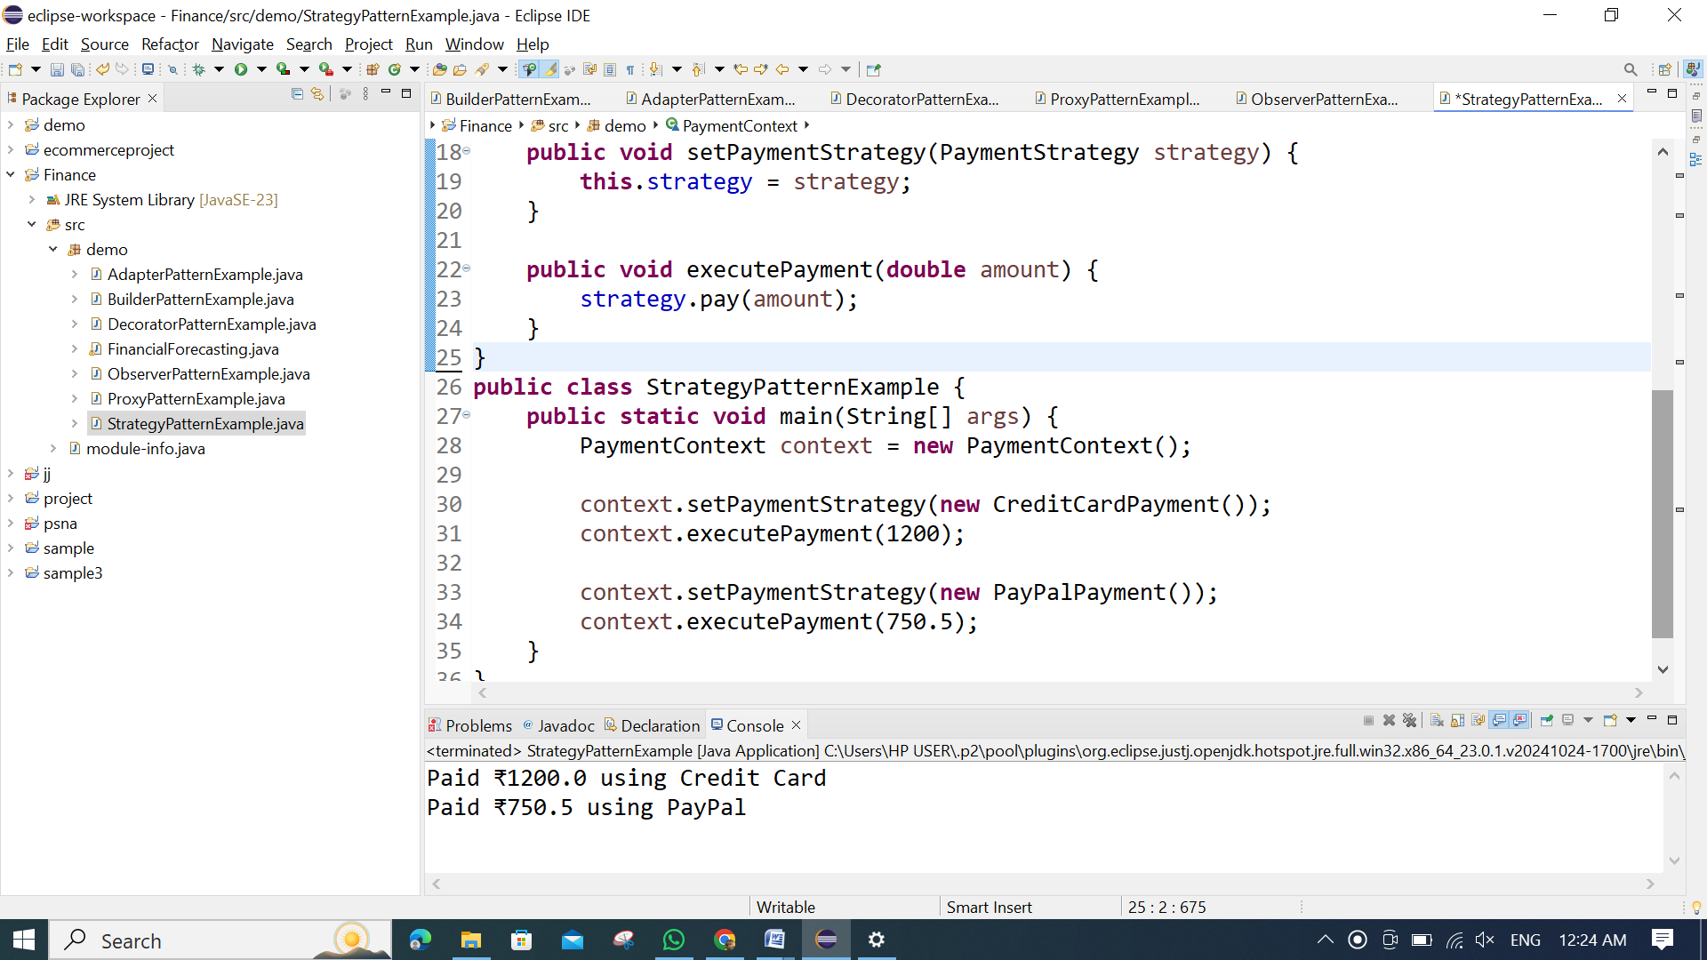

**OUTPUT:**

